Prepared by P1WS 10/13/17
Questionnaire #1 - Jeff & Shelley to Answer

How Will Your Audience Use The Website?
- What audience types/personas are visiting and interacting with your website?
- EHS&S department
- Engineers
- Technicians
- Plant managers
- WWT
- Distributors

- Can you prioritize the importance of each audience type/persona to your business?
Each visitor to our site is just as important as the next. If it came down to categorizing for importance the emphasis should be placed on those individuals who are looking for a solution that we have (aka the contacts which we can sell to). If someone cannot get an SDS on our website there are ways around that, but if someone does not see HH as an expert after visiting our website there is a potential for loss revenue. (To point it simply, the person who is just coming to our site for logistical reasons would have to be named the secondary focus).

- Can you name and briefly describe each types/personas unique challenges and needs?
- EHS&S department: Need an SDS, have to watch a video – they require content to complete their job function. Could also be something reported related.
- Engineers, Techs, and Plant managers: looking to improve productivity and efficiencies.
- WWT: the plant is shutdown, they can’t meet discharge requirements
- Distributors: availability of products; essentially an extension of our sales team. Could be looking for SDS, Product Bulletins, or general content.

- What is each audience type/persona looking for? (What section of the site will they visit?) What are their goals with the website?
- EHS&S department: looking for SDS sheets & need to watch safety videos – need to satisfy regulations
- Engineers, Techs, and Plant managers: looking for answers / solutions, want to improve cost, process improvement, increase productivity. Could be looking for information on to be more LEAN.
- WWT: eliminate pain / alleviate regulatory pressures.

How Will The Website Impact Your Business Goals?
- What are your business goals for this website? (Ex. Do you want to drive phone calls or form fills?) Can you prioritize these goals for your business?
Driving sales is our #1 goal. To do this our website needs to be structured in a cohesive manner that is also optimized for SEO. Subsequent to that would be developing/increasing our contact database for lead nurturing campaigns, thus having forms on our website for applicable content that demonstrates our expertise is critical.

- What do you want the site to effectively be able to do? (Ex. Educational/Sales Driven)
- Lead generation & conversion.
(It is imperative that the leads are of some substance, we do not want to spend resources – time and money – just to see an increase in site sessions that does not amount to anything actionable). This ultimately leads to the website being optimized to aid with conversions: MQL → SQL
- Showcase HH as a SME.
We have 168 years in the industry and we need to tell that story in a compelling manner. We provide solutions to manufacturing’s toughest problems – the ones other companies walk away from – our website should be formatted to showcase us in that light. Evolutionary yet steeped in tradition.
- Allow current customers to complete necessary transactions.
(ex. Download SDS and watch safety videos)

- Can you prioritize those goals in order of importance to your business?
See above – already in priority order

Questionnaire #2 - To Ask Staff*
A survey was sent out to a cross-section of our employees. We had a 89.5% response rate (17 out of 19). The functions of those surveyed included: leadership, sales, technical, and engineers. It was sent to employees with tenure less than 6 months and those with storied-tenures, as well as various generations.

- What do you like about the website?
- Can clearly navigate
- It is easy to navigate
- Color scheme is vibrant and modern. Drop down options are well segmented.
- Remanufacturing landing page. This page uses industry terms rather than terms HH is comfortable with/used to using. There are before and after images as well as charts – you know why you are on that page and that we understand your industry.
- The new landing page.
- The setup of the homepage - scrolling banners with metrics, the 4 icons that lead to various places on the website that are clearly defined.
- There is a lot of information available, especially training
- I like the look and ease of navigation, very clean and visually appealing
- It projects that we are a large company.
- it's pleasing to the eyes. not too busy and easy to navigate. I especially like contact information is really easy to find. many sites I come across I almost feel they make it difficult to find a number on purpose. almost as if they are forcing you to contact them via the web. many people still want to speak to a person.
- It's very intuitive. There are a large amount of pages that can be accessed off the home page without looking too "busy".
- There is lot of valuable knowledge behind the content. We should make that apparent. If a 5 year old can't understand, you aren't explaining it well.
- graphics
- Clean, high quality look, particularly on the homepage
- Overall design/aesthetic.
- Modern big picture look. Classy. Lots of information

- What do you not like about the website?
- Need login for SDS
- Access to videos and SDS are difficult
- The home page is pretty busy and I could see it being difficult for someone to get to products that apply to their industry/application.
- Don't like our homepage. It is not obvious what we are. Focuses on products rather than solutions. Needs more before and after/success stories.
- The logo.
- While it is important to have a plethora of content to demonstrate our expertise, there are different ways in which we can layout the content that is more digestible/visually appealing. I also think we should have more forms to collect contact information.
- It can be more eye-catchy
- I think there are probably too many drop downs and it does not fill the screen
- It seems boring.
- we don't have the option to 'chat' for those people who want to communicate that way
- On my small vitual-machine tower, the site loads slowly because of all the graphics and can lag between different pictures.
- The about us page isn't personalized. We say we are customer-centric but the website isn't easy to navigate nor does it have pictures/stories of us and the companies we work with. The blog hasn't been updated. The search bar disappears and isn't readily noticeable. Our number doesn't stand out in the top right. Can't always determine what is a link and what is simply bold and highlighted for emphasis. Each chemical listed A-Z should allow for a hover over caption containing the sizes offered. Too many narrowing pages to get to a product with minimal flow. Shouldn't have so many words. A current customer can't log in and see there previous orders, access SDS'/product bulletins, or order more chemistry. We should have a live chat as another interface. Careers section doesn't have our job postings.
- some information is difficult to find
- Internal pages are not optimized. Search feature doesn't work very well.
- The website is informative if you are looking for information about HH - but I'm not sure what it does for you if you are an existing customer
- Simply too much content. Needs to be trimmed. "About us" section is limited. Our expertise doesn't seem to be branded much. Who is our expertise? Missing some features that new distributors are offering. Live chat, online ordering, live access to COA, SDS, Certs. http://www.chemworld.com/

- If you could change one thing about the website what would be?
- Make access to videos easier
- Create a main segment page so that customers can find products specific to their application more easily.
- Become a solution provider and not a list of products.
- I would suggest two things: 1. Focus more on the customer - in the language that is used and how navigation tabs are setup 2. More infographics, graphics, testimonials, and metrics that stand out
- more pictures/videos
- I think the search criteria would be great if it was intuitive
- I would add a section called "I have a technical problem" where customers could write in with questions or issues and we can have someone follow up.
- the capability to order on line but I know there are a lot of obstacles
- How quickly it cycles through background images. It causes a lot of lag on my machine, but it's probably not as noticeable for most people.
- Easy to navigate.
- More customer testimonials
- Specific contacts for visitors. Ex: Wastewater visitor, provide Reps info. on site.

Additional Questions on Staff Survey

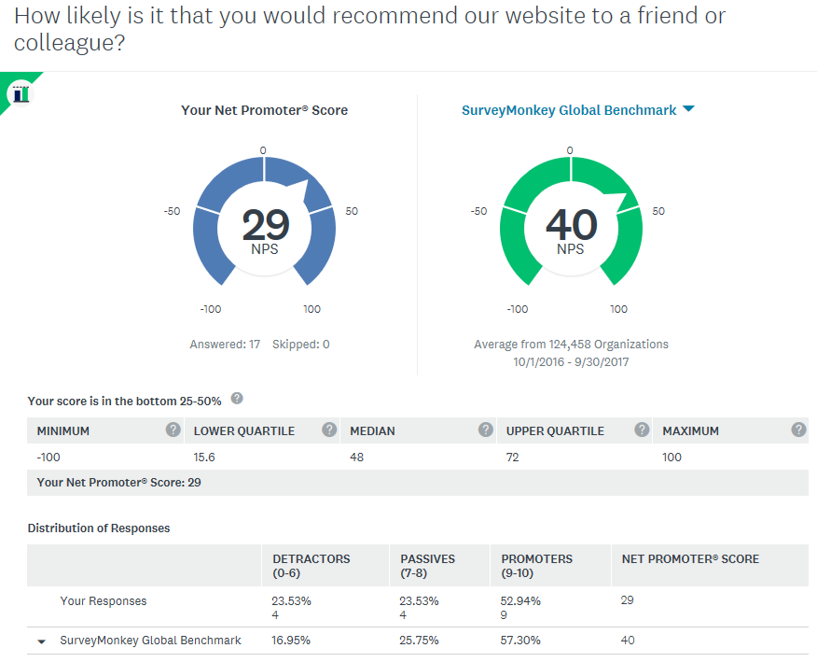

Summary of Staff UX Brainstorming Session
A group of ten employees met for 2 hours to discuss some ideas they had about the website. Our session started with a warm-up exercise of “why Hubbard-Hall?” Resoundingly the answers centered around our 168 history, reputation, the peace of mind we offer our customers (to encompass customer service and knowledge/breadth of experience), the variety of products offered, and the relationships we develop with our customers.
Which lead to – “how to demonstrate to the audience…”
We know that our customers do not want to be “the first” with a chemical/process unless there is a major pain or significant value. That is why we know that having more testimonials/call-out quotes, videos and metrics is important with this next website iteration.
One of the goals we came up with was to be the Wikipedia of our industry.
Enhancements discussed:
- Better search function. Our search bar disappears sometimes mid-typing, does not always show results for chemicals that are researched, and is not intuitive
- The ability to pull a report of customers who downloaded SDS or watched videos
- Highlight our events better
- Optimize our pages for Google
- Hoover over a chemical to see what container sizes are available
- Use words that the industry knows vs. those that we use
- Have more information on our homepage
- Display our problem solving skills, today the site is too product specific (answer the pain points)
- Use banner images that help a visitor to our site recognize that we are a chemical company – the site now is great for someone who knows us but not for someone who is a prospect
Other websites that were discussed:
Industry Related
- Top product landing page idea: Stepsol Met-10U. Liked that there was a description of the chemical and associated documents.
- ChemWorld: contact bar. This opened a discussion on contact us form vs. having an email open-up and how people in this discovery group do not like the contact us form – it is viewed as daunting and formal.
- EPI: product description
- Brenntag: product finder, ID yourself, use of homepage
- Chempoint
- Hydrite
- Atotech: automotive competency page
Non-Industry Related
- Seattle Space Needle page: like the imagery and how when you scroll you find out facts. The creativity of this lends itself to vibratory/tumbling, paint stripping, or something being colored.
- CDF: literation and addresses 3 pain points that the firm addresses.

Summary of Customers 1:1 (to date – 10.25.17)
To date we have talked to four customers. Three of them average 25 minutes per month on the site and the fourth rarely goes on the website. Of the three that do visit the site they have all been long standing customers and typically use the site to download an SDS or watch a video.
Suggestions that they made:
- Track my order online
- Live chat
- View buy history on website
- Prompt to buy X product based on other purchases or customers like you buy this as well
- Have information about state regulations on the website or a link out to applicable sites
The NPS score was in the negative zone but this is unreliable as this was such a small sample size and the customers are reliant on the relationships that they have with their sales and tech reps.

